Concise Body Arrow Functions

JavaScript also provides several ways to refactor arrow function syntax. The most condensed form of the function is known as *concise body*. We’ll explore a few of these techniques below:

* Functions that take only a single parameter do not need that parameter to be enclosed in parentheses. However, if a function takes zero or multiple parameters, parentheses are required.
* 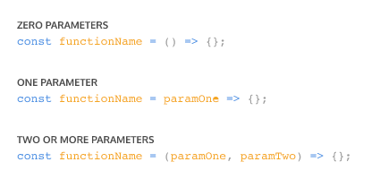
* A function body composed of a single-line block does not need curly braces. Without the curly braces, whatever that line evaluates will be automatically returned. The contents of the block should immediately follow the arrow => and the return keyword can be removed. This is referred to as *implicit return*.

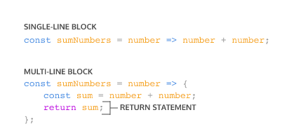

So if we have a function:

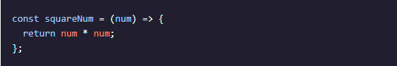

We can refactor the function to:



Notice the following changes:

* The parentheses around num have been removed, since it has a single parameter.
* The curly braces { } have been removed since the function consists of a single-line block.
* The return keyword has been removed since the function consists of a single-line block.